Institute of Computer Technology

B. Tech Computer Science and Engineering

Subject: Basics of Communication Systems (2CSE202)

**PRACTICAL-EXAM**

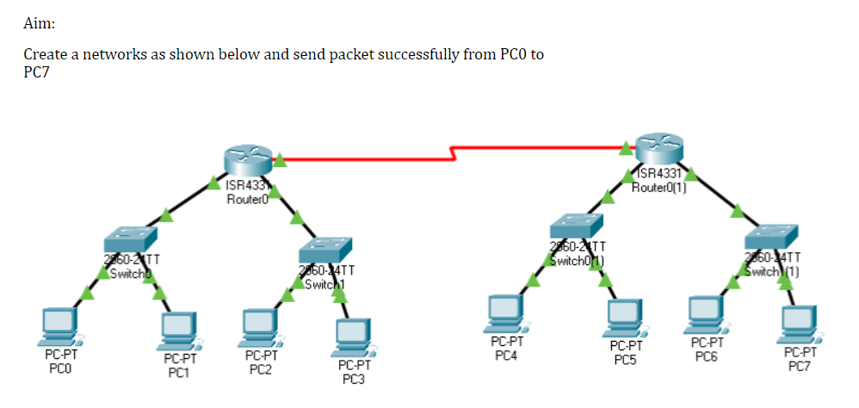

***SOLUTION:***

* Step 1: Create the given network with the help of Routers, Switches and PCs.
* Step 2: Router does not have enough ports to connect to other router, so we need to add extension ports to both the routers using “ **NIM-2T** ”.

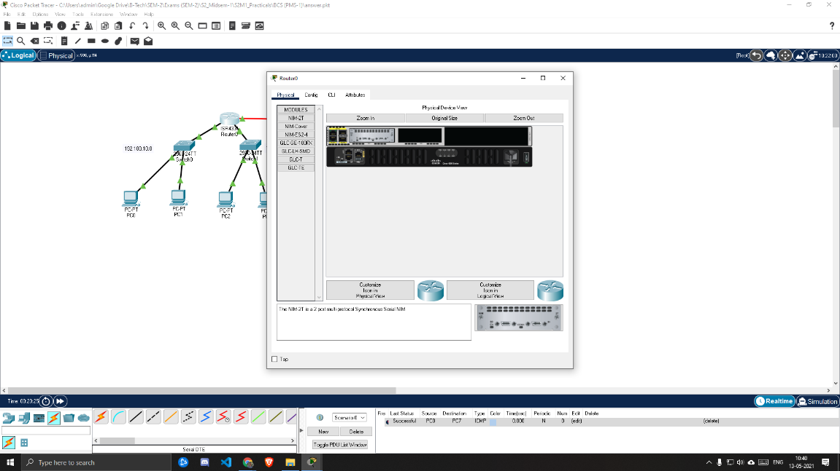

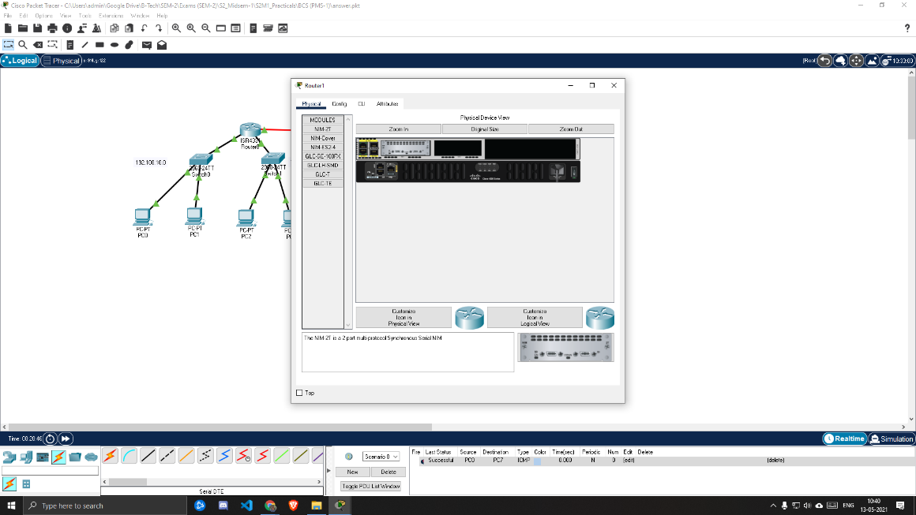

* Step 3: Connect all the devices with appropriate cables and turn ON the ports on both the routers.
* Step 4: Configure the ROUTERS and PCs according to the following: -

***FOR ROUTERS***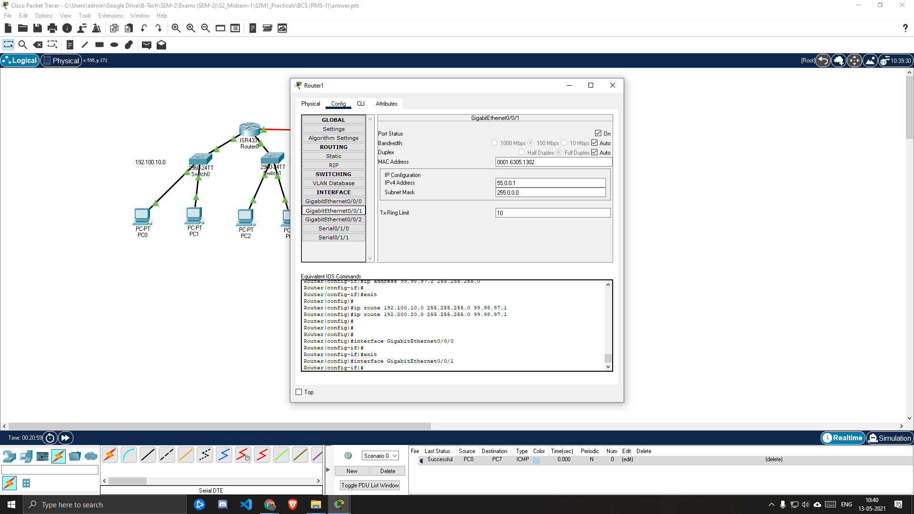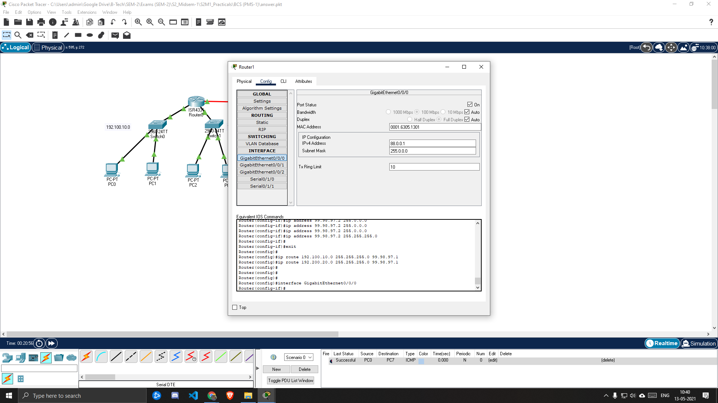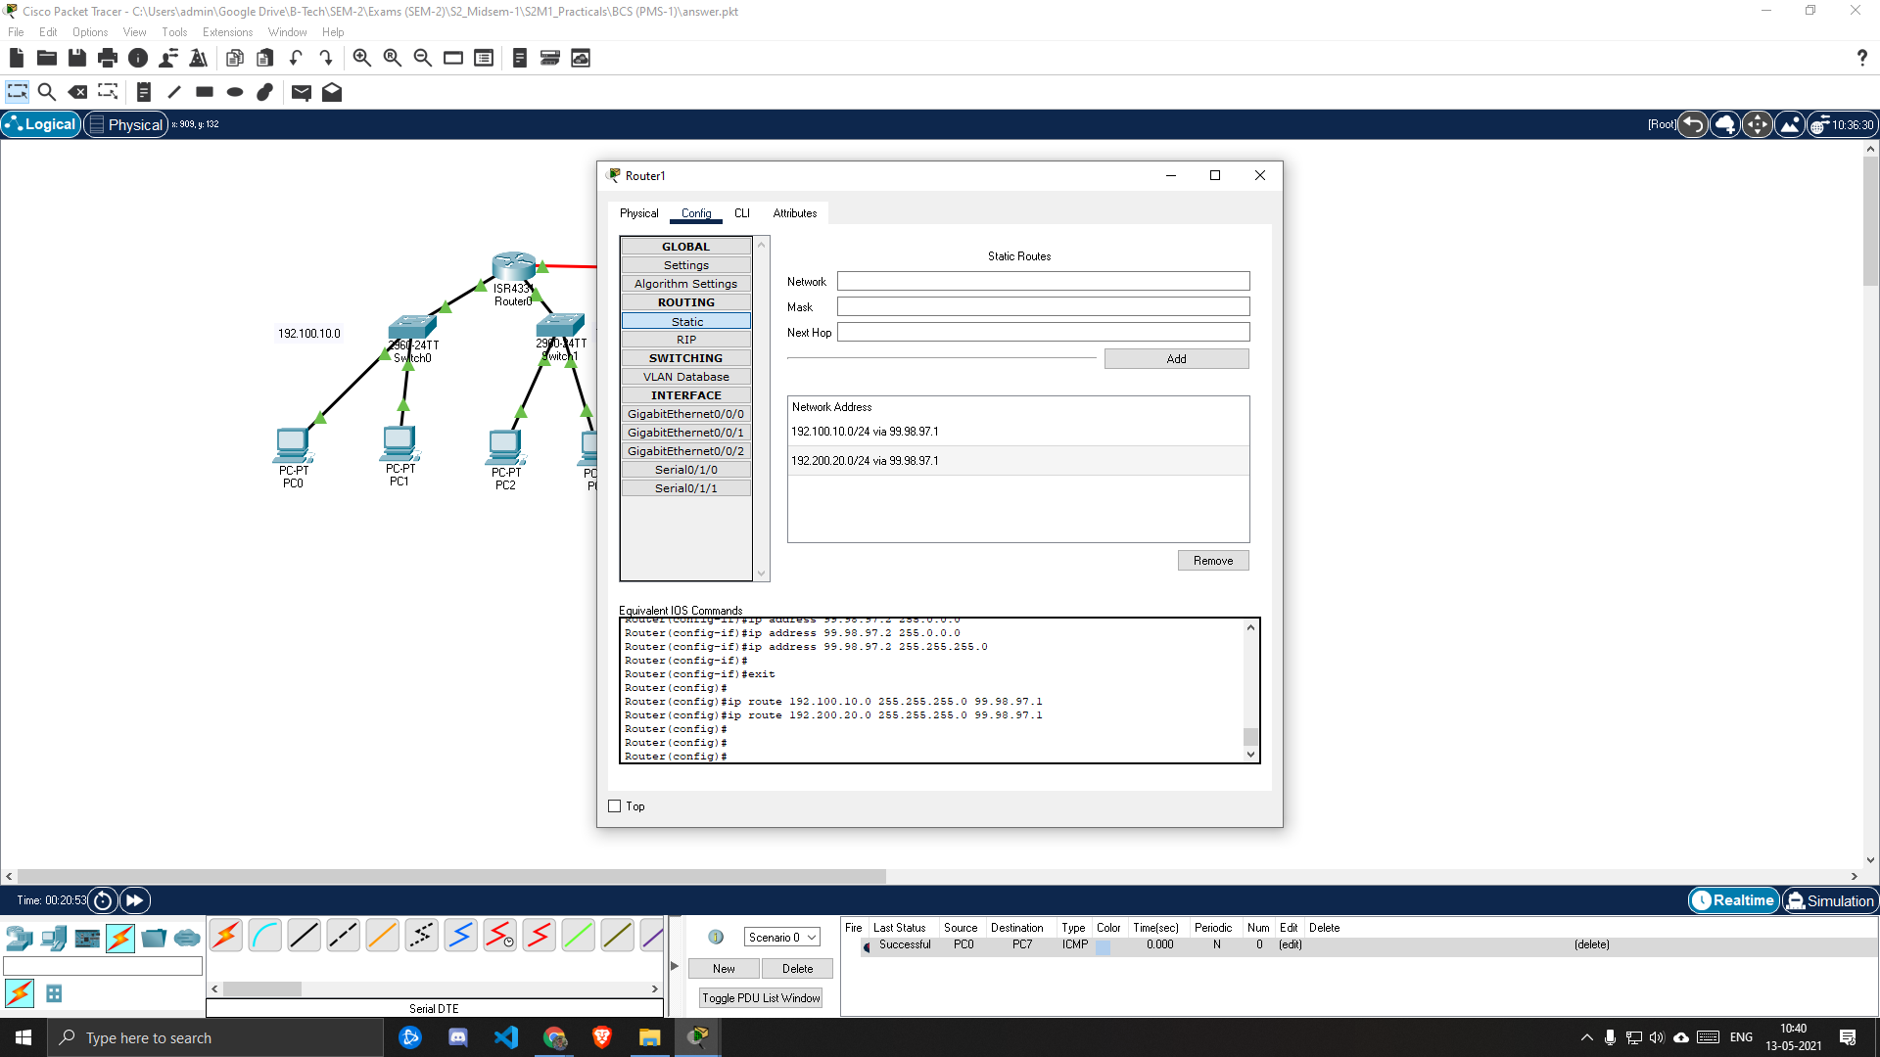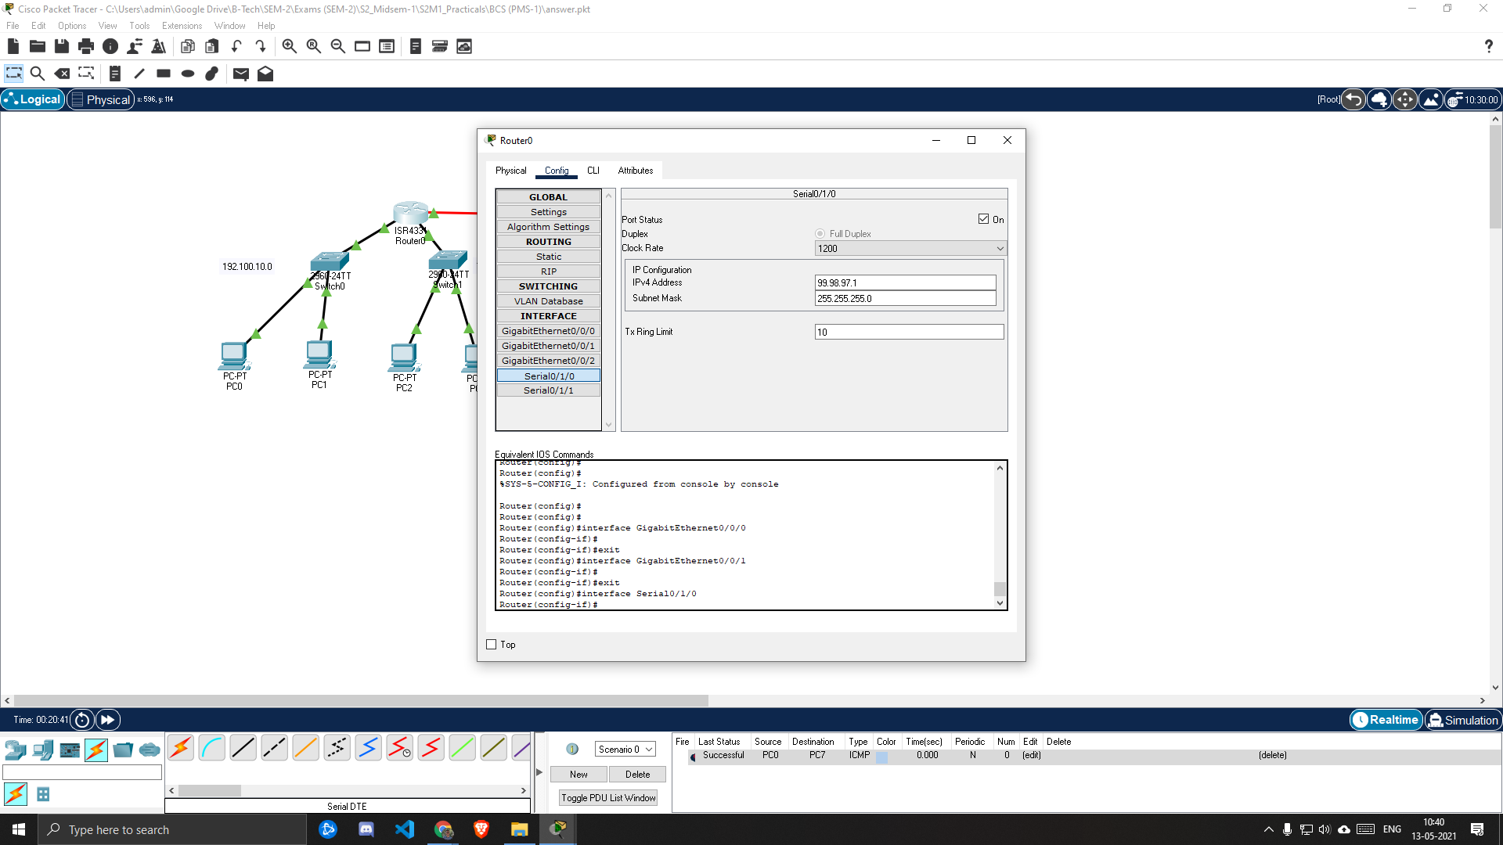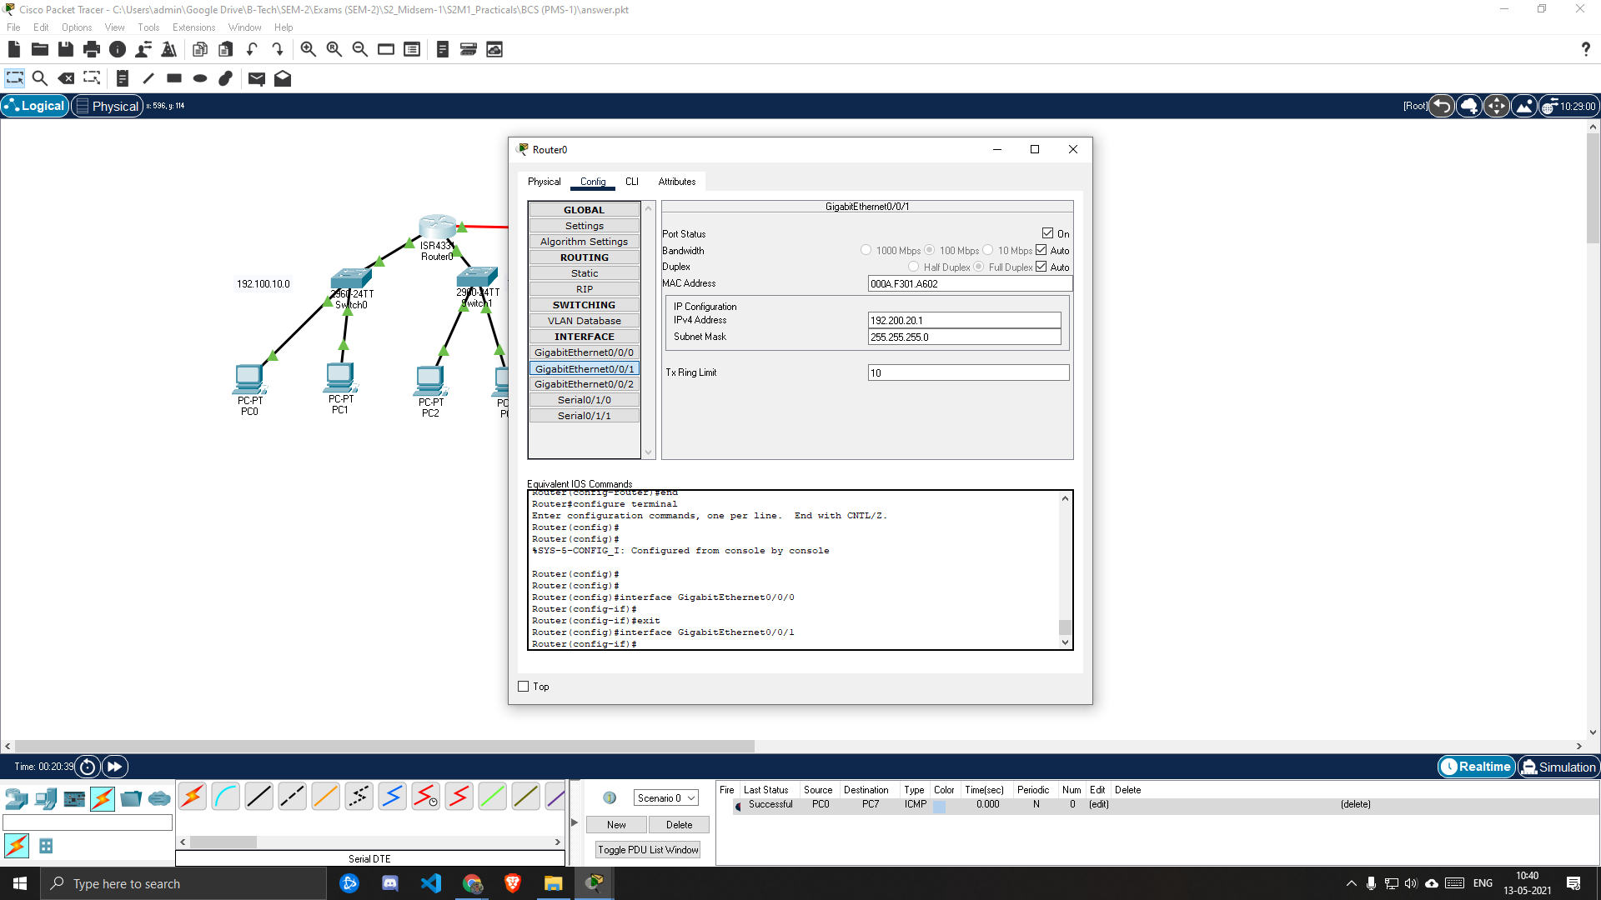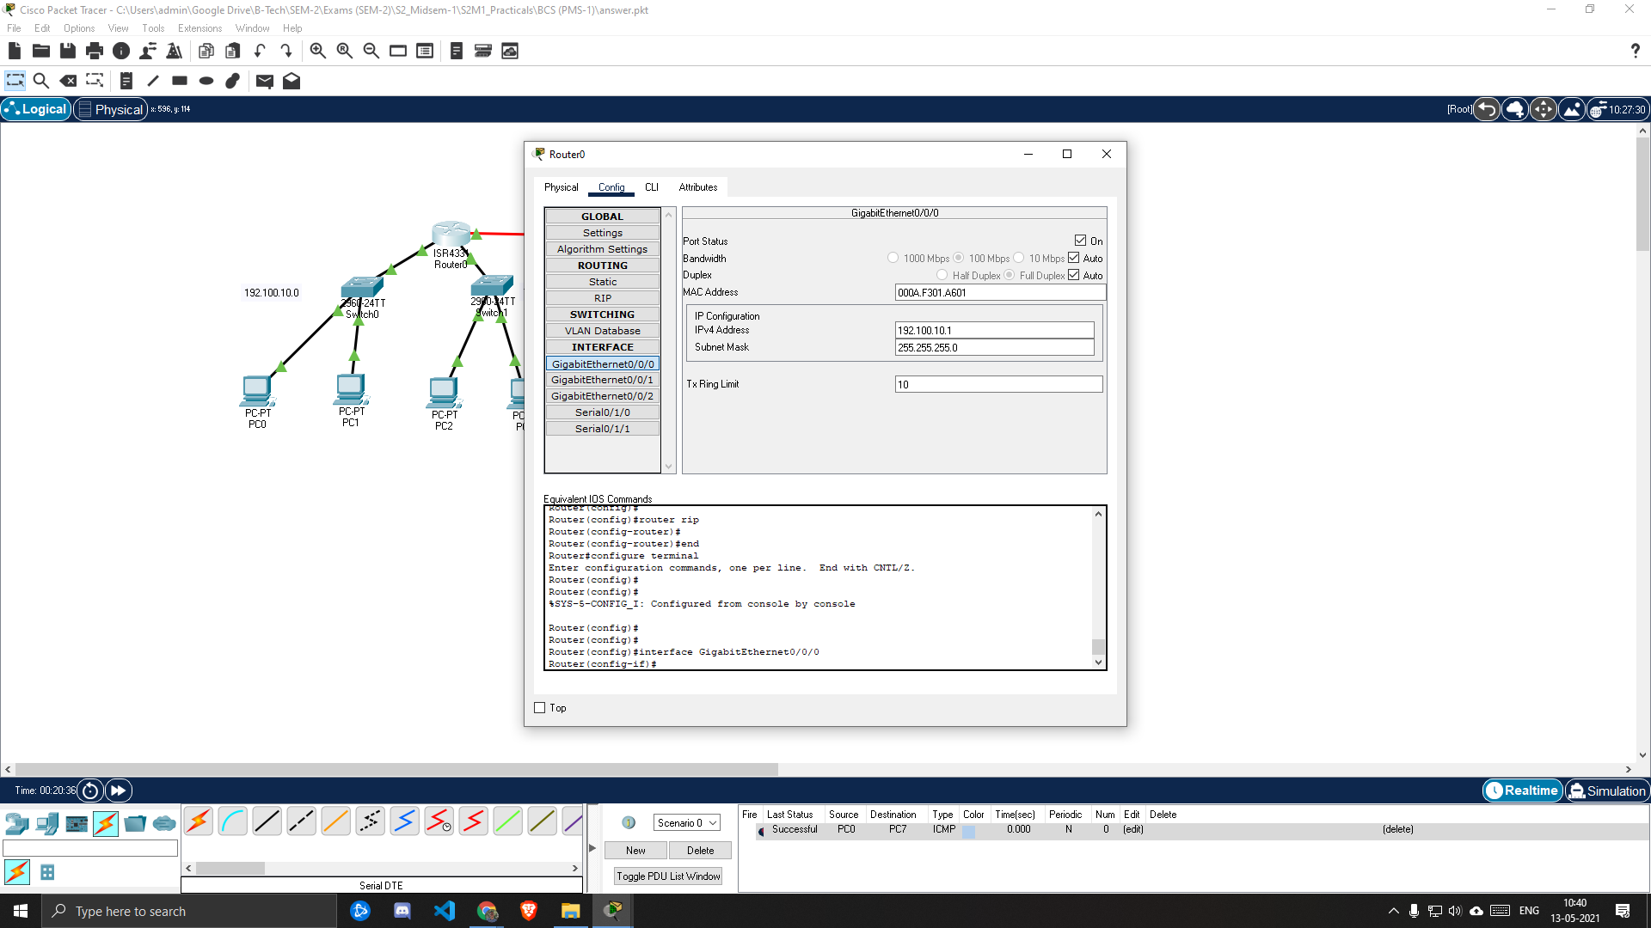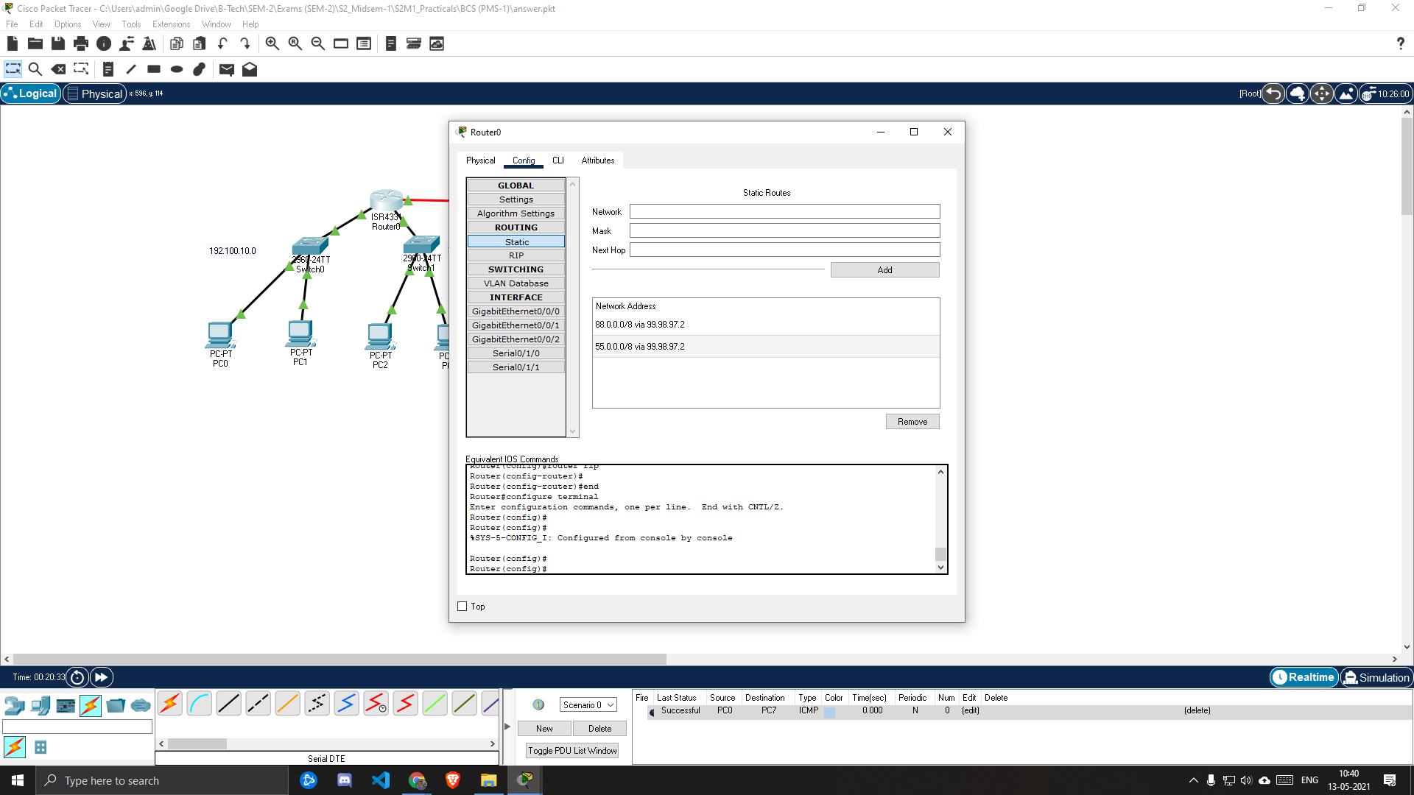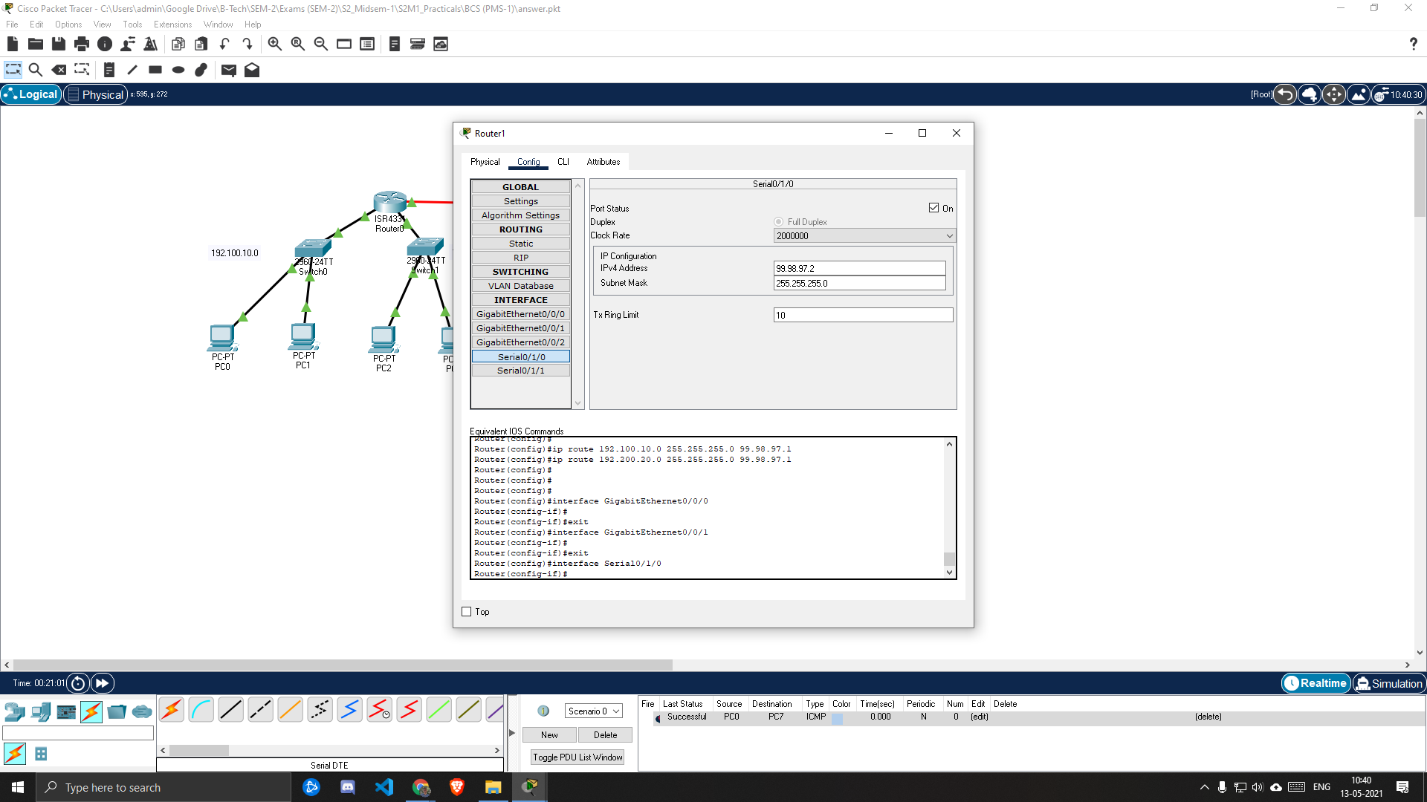

***FOR PCs***

1. ***PC0***

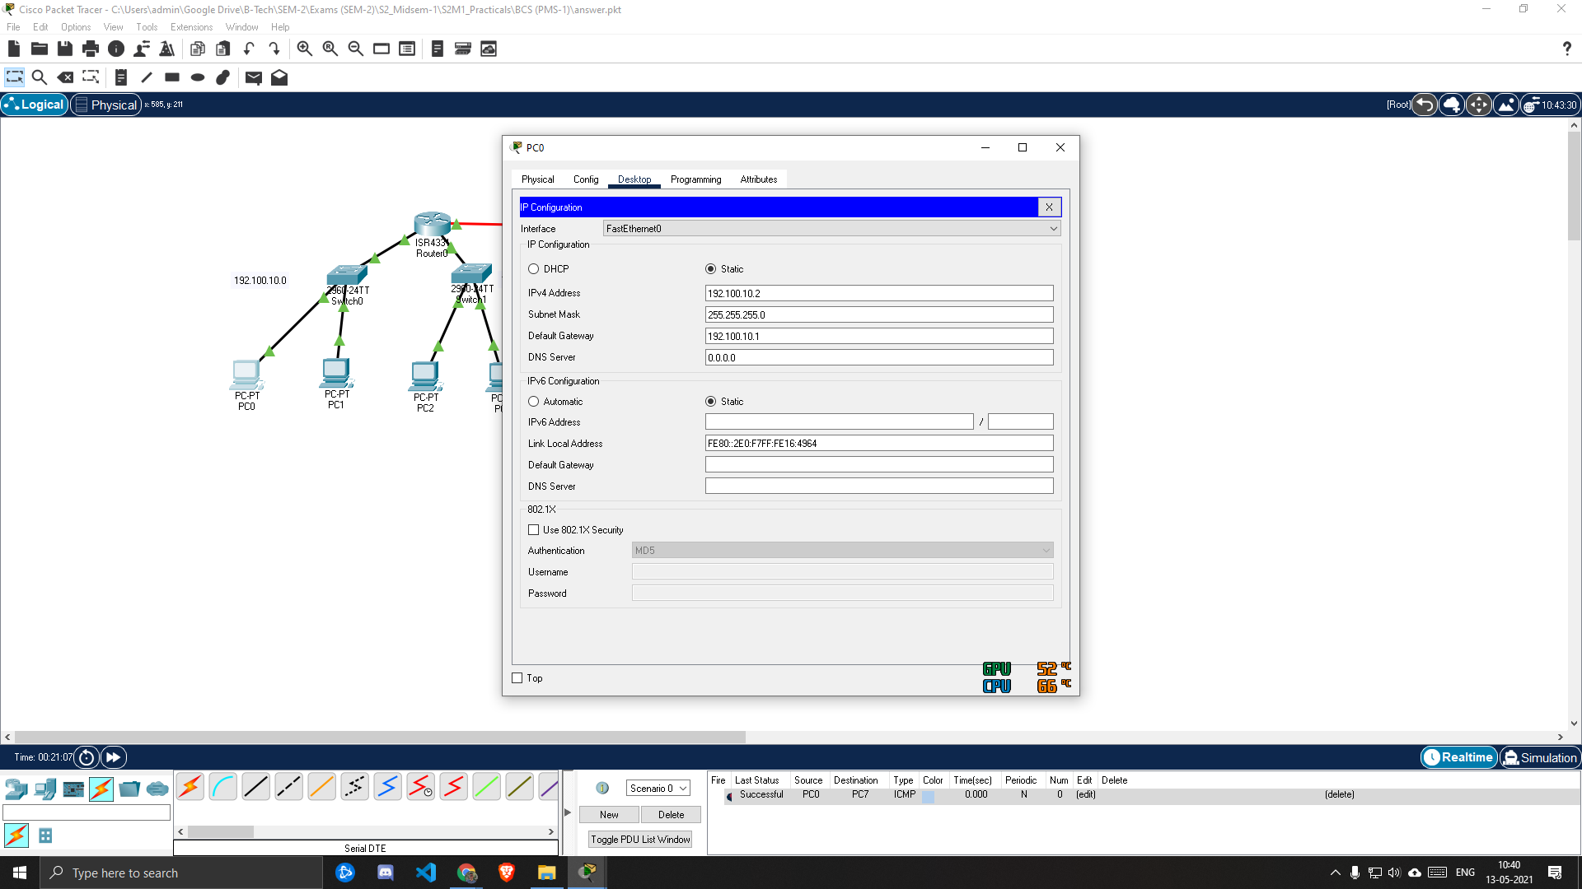

1. ***PC1***

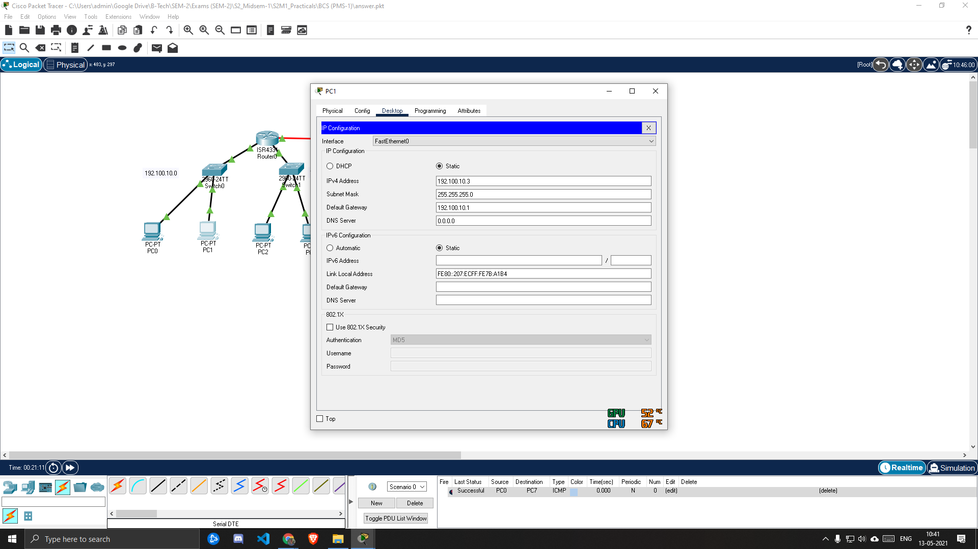

1. ***PC2***

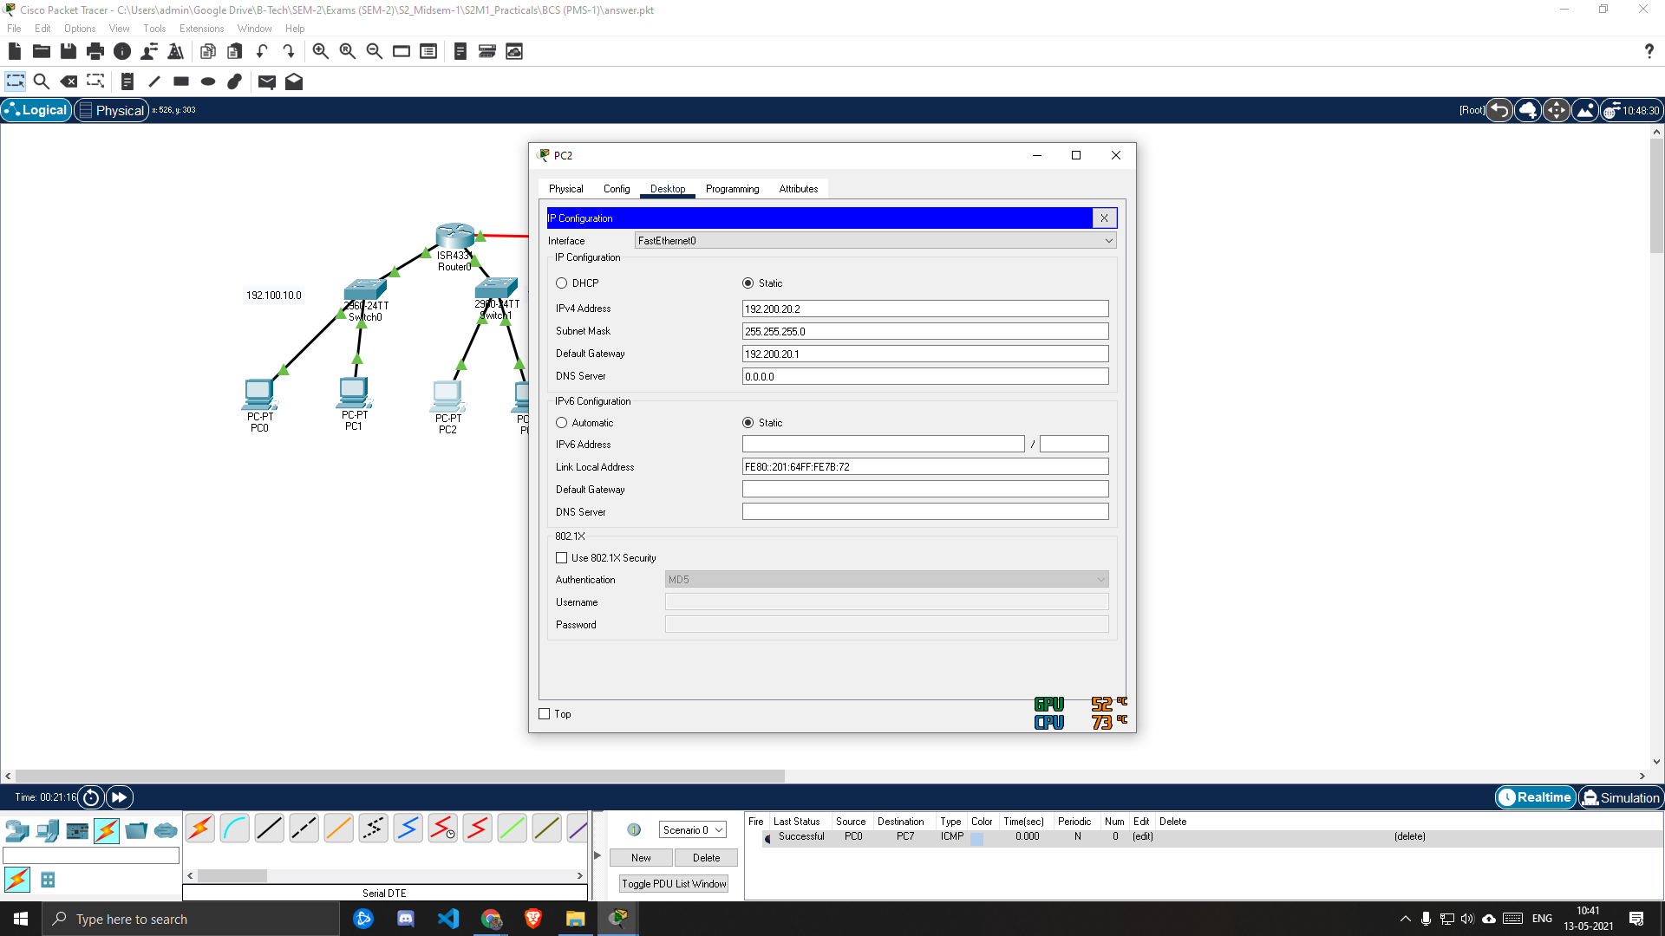

1. ***PC3***

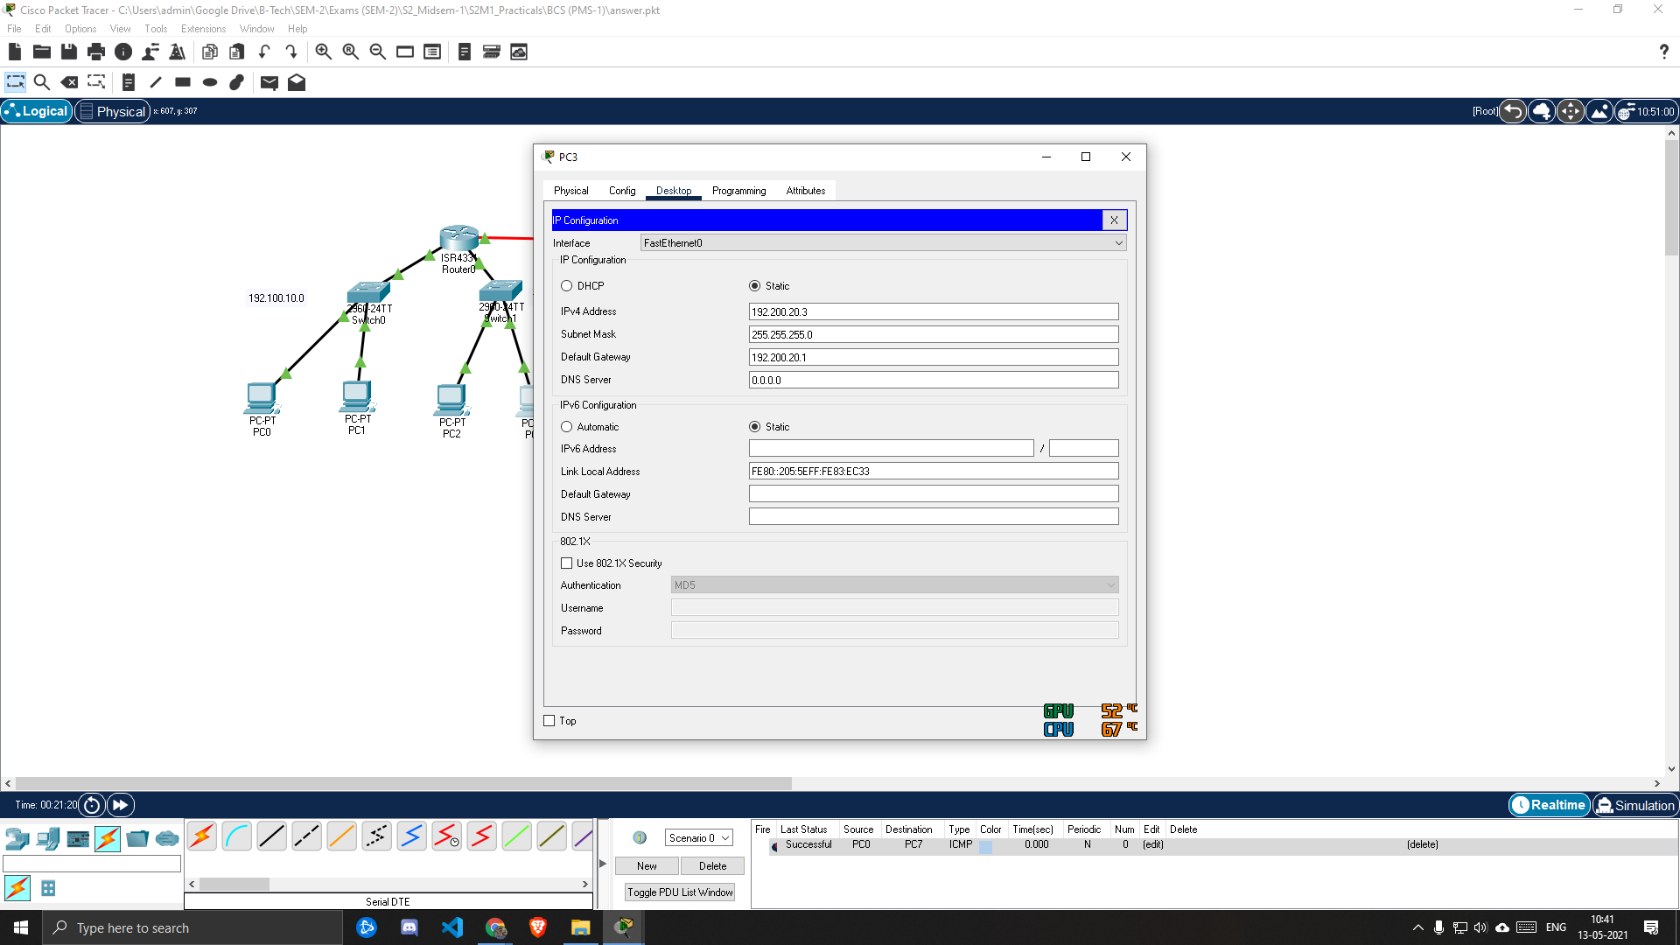

1. ***PC4***

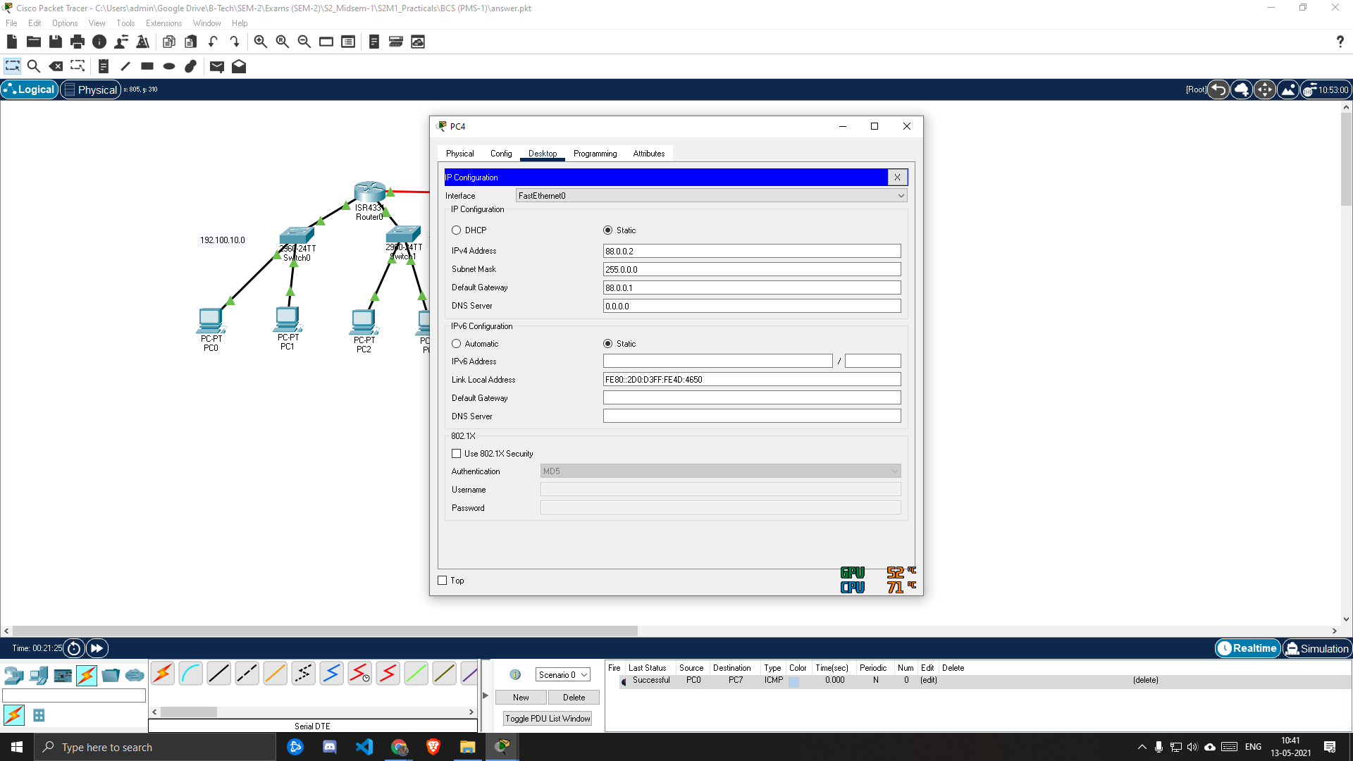

1. ***PC5***

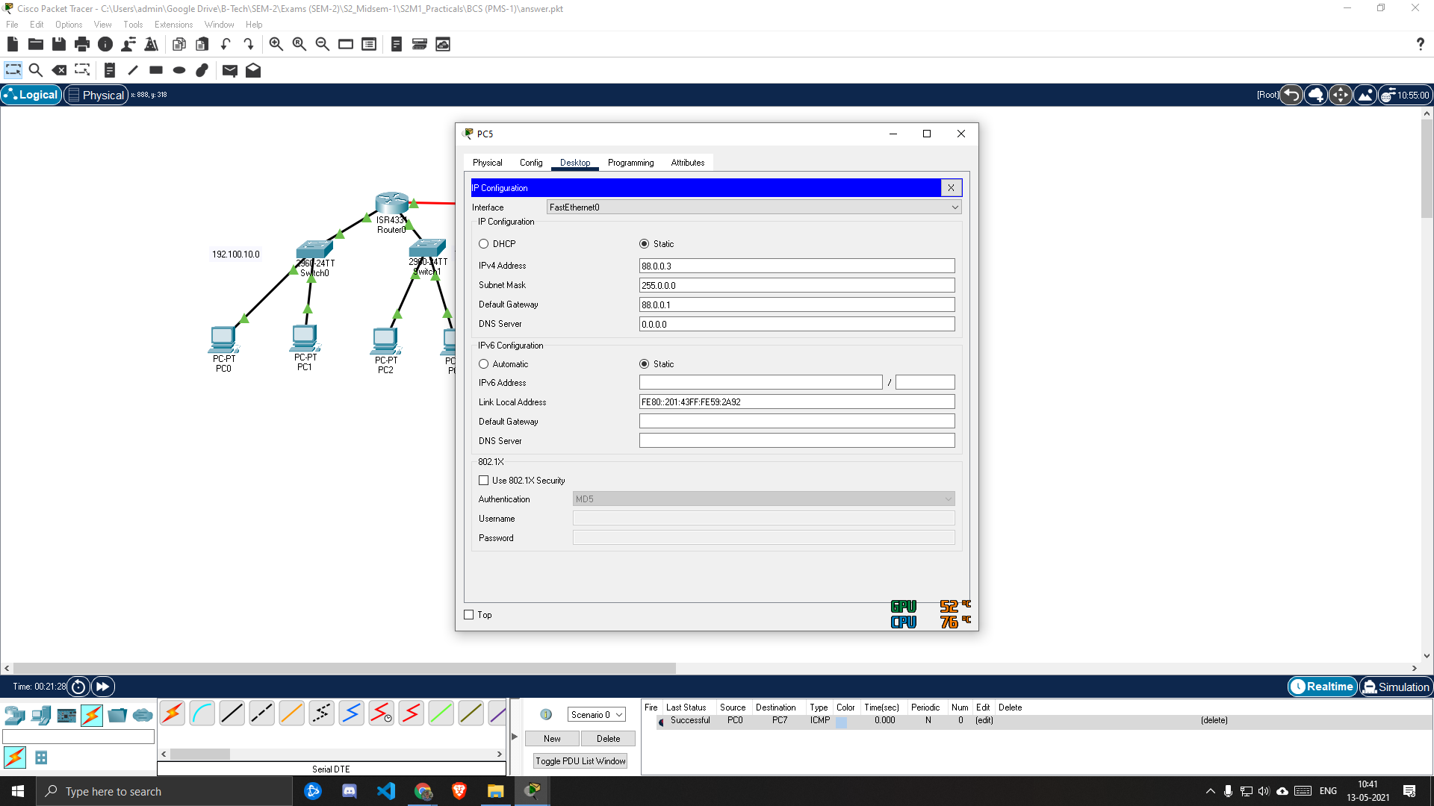

1. ***PC6***

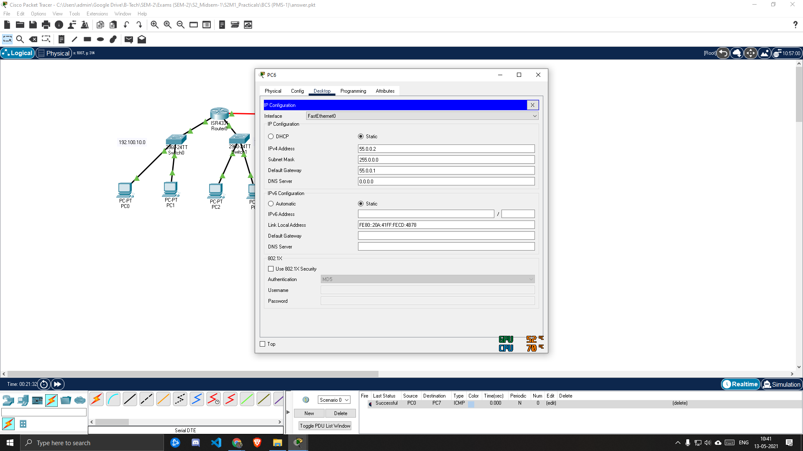

1. ***PC7***

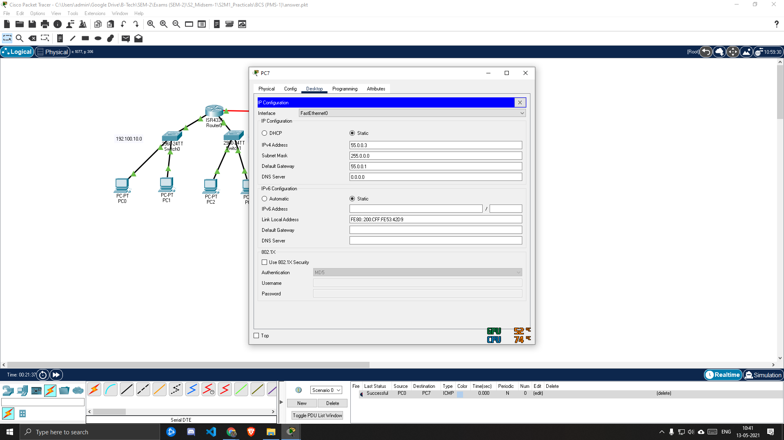

* Step 5: Now as the connections are done, all PCs are connected to each other.
* Step 6: The connections is according as below.

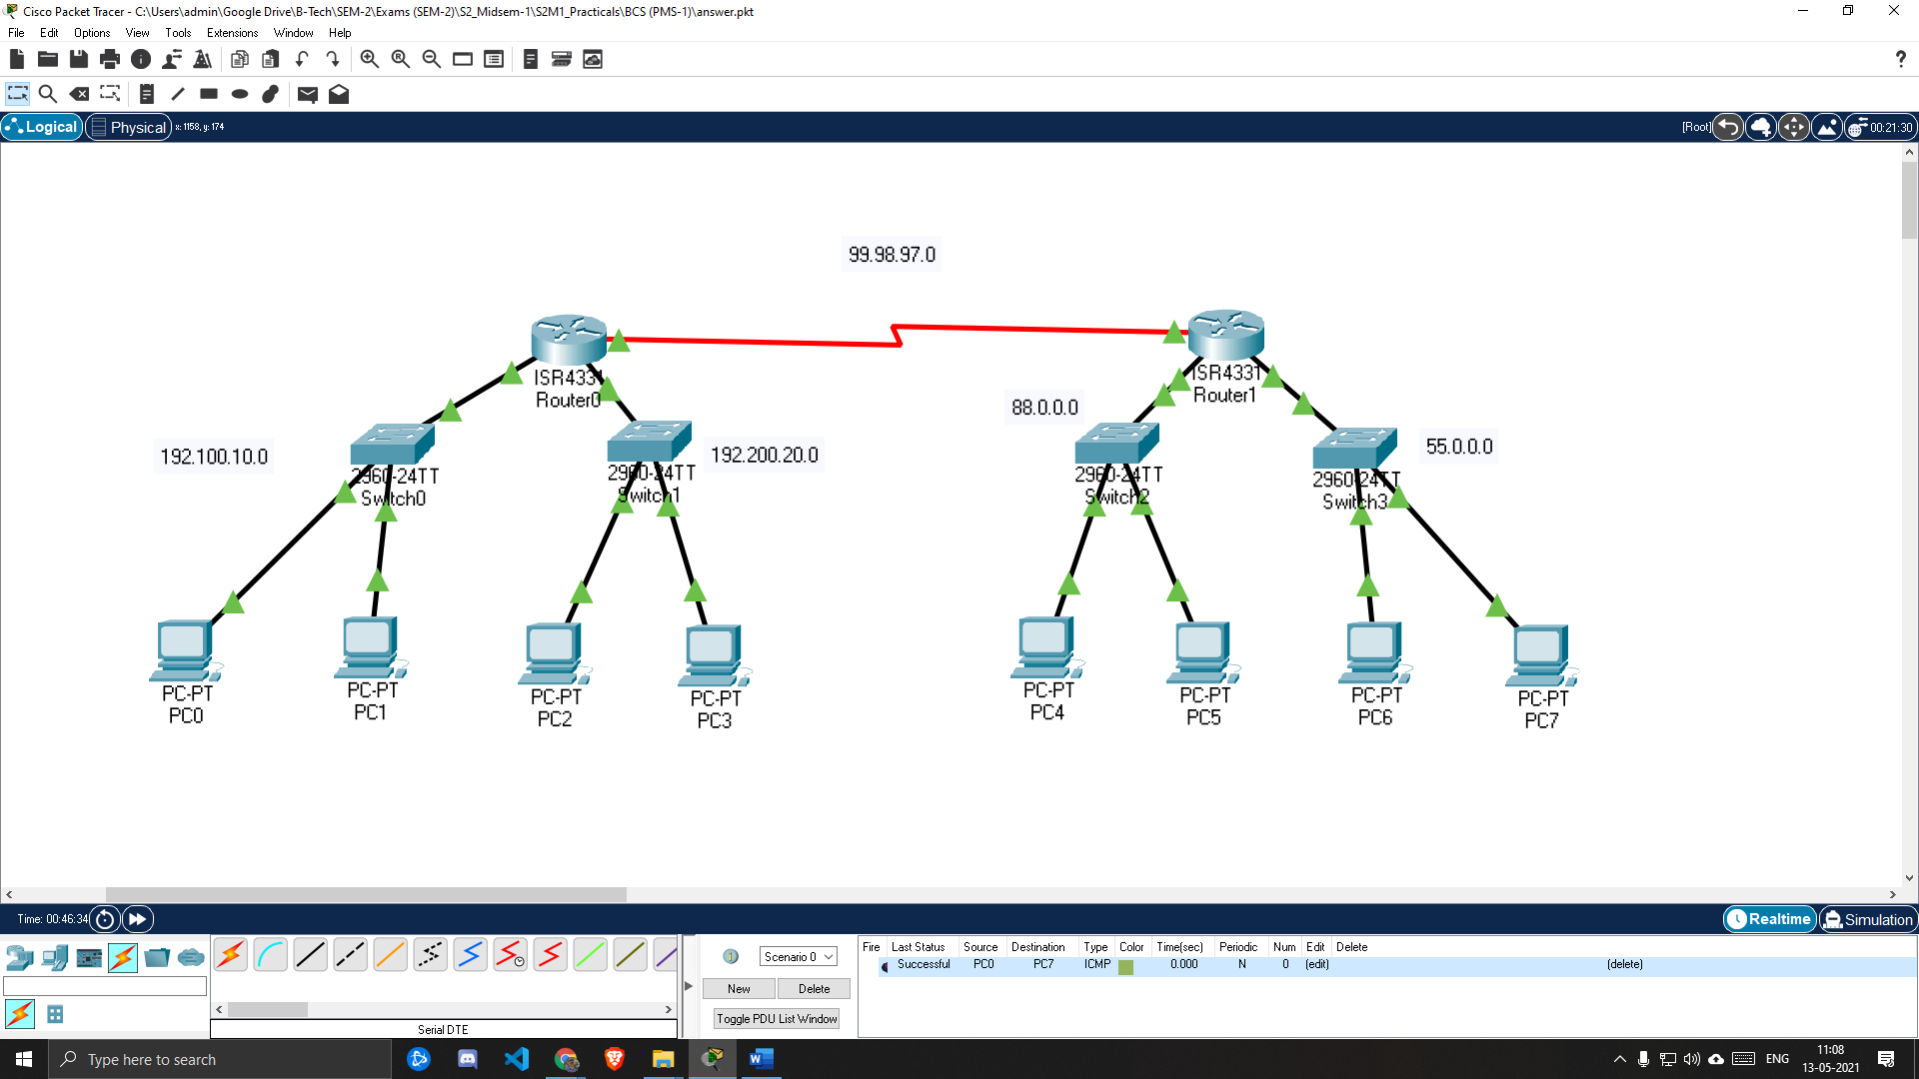

* Step 7: Now according to question, we have to send packet from PC0 to PC7.

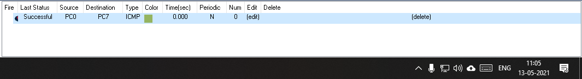

***CONCLUSION:***

Hence by doing this practical we conclude the study and designing of computer network according to question.